Category 1: Core Technical Knowledge
These questions test your fundamental IT engineering skills.
A) Database Management:
- Explain the differences between SQL and NoSQL databases. In what scenarios would you recommend a NoSQL database for an insurance company like NICL?

Answer:
"Sir/Ma'am, SQL and NoSQL databases represent two fundamentally different approaches to data storage and retrieval. The core differences can be summarized across five key aspects:
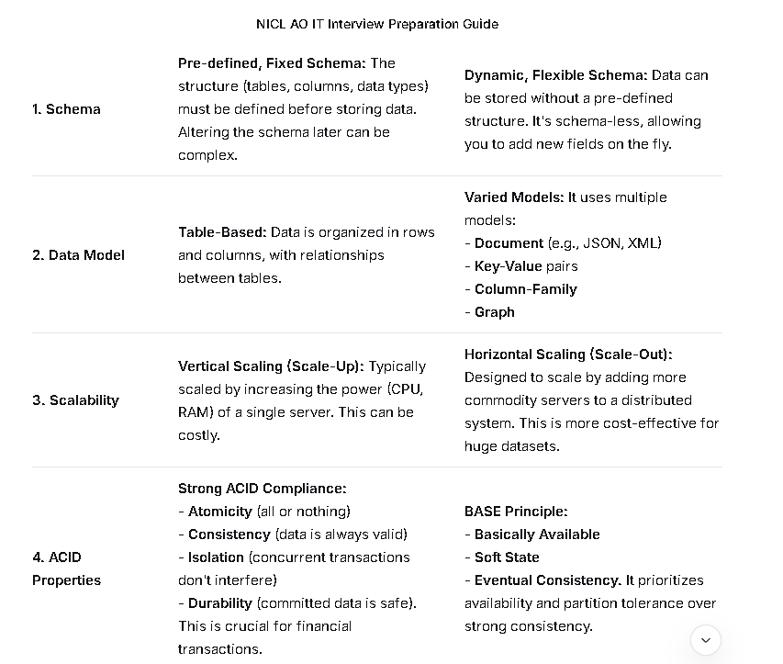
- What is database normalization and why is it important? Can you describe the different normal forms?
Answer:
"Sir/Ma'am, Database Normalization is a systematic process of organizing data in a database to reduce data redundancy and improve data integrity.
For an organization like NICL, which manages critical policyholder, financial, and claim data, normalization is not just a technical best practice; it's a business necessity. Its importance can be summarized in four key areas:
The same data, like a customer's name and address, might be repeated in every policy and claim record they have. This wastes storage space.
If a customer changes their address, we would have to update it in every single record where it appears. If we miss one, the data becomes inconsistent.

1. First Normal Form (1NF) - The Foundation
- Rule: Eliminate repeating groups of columns and ensure each column contains only atomic (indivisible) values.
- Problem in our table: If one policy can have multiple phone numbers, they might be stored in a single column like "98765-43210, 91234-56789". This violates 1NF.
- How to fix it:
  - Ensure each column has a single value. We might need a separate CustomerPhones table.
  - Define a primary key (e.g., a composite key of PolicyID and another column if needed).
- Result: Our data is now in a basic, tabular format.
2. Second Normal Form (2NF) - Remove Partial Dependencies
- Rule: First, the table must be in 1NF. Second, all non-key attributes must be fully functionally dependent on the entire primary key.
- Problem in our table: Let's assume our primary key is (PolicyID, AgentID).
  - Attributes like CustomerName and PlanType depend only on PolicyID, not on the combination (PolicyID, AgentID). This is a partial dependency.
- How to fix it: Move the partially dependent attributes to a new table.
  - Create a Policies table with PolicyID as the primary key and include CustomerName, PlanType, Premium.
  - The original table can be renamed to PolicyAgents with just PolicyID and AgentID.
- Result: Data is now grouped by its direct relationship to the primary key.
3. Third Normal Form (3NF) - Remove Transitive Dependencies
- Rule: First, the table must be in 2NF. Second, no non-key attribute should be dependent on another non-key attribute. In other words, all attributes must depend only on the primary key.
- Problem in our Policies table:
  - AgentName depends on AgentID, which is not the primary key of this table. AgentID is a non-key attribute here. This is a transitive dependency.
- How to fix it: Move the transitively dependent attributes to a new table.
  - Create an Agents table with AgentID as the primary key and include AgentName.
  - The Policies table will now only have PolicyID, CustomerName, PlanType, Premium, and AgentID (as a foreign key).
- Result: There are no dependencies between non-key columns. Each non-key field is a fact about the key, the whole key, and nothing but the key.

How would you handle a scenario where a database is running slow? Explain your step-by-step troubleshooting process.

Answer:
"Sir/Ma'am, a slow database is a high-priority issue, especially in an insurance environment where it can directly impact customer service, agent operations, and financial transactions. My approach would be systematic, starting with the simplest and most common causes before moving to more complex ones. I would follow this escalation path:
Phase 1: Immediate Triage and Initial Diagnosis
- Acknowledge and Communicate: First, I would acknowledge the issue reported by users and inform the relevant stakeholders (e.g., my manager, the application support team) that we are investigating a performance degradation. This manages expectations.
- Gather Information: I would ask key questions to narrow down the scope:
  - Is the slowness universal or specific? Is it affecting all users and all operations, or just a specific application, a particular branch, or a single type of transaction (e.g., claim settlement report)?
  - When did it start? Did it happen suddenly at a specific time, or has it been gradually getting worse?
  - What has changed? Was there a recent application deployment, a schema change, a significant increase in data volume, or a batch job that runs at that time?
Phase 2: Investigating the Database Server Itself
With the initial context, I would log into the database server and check the following, often using built-in tools and dynamic management views:
- Check Basic Server Health:
  - CPU, Memory, and Disk I/O: I would use OS-level tools (like top in Linux or Task Manager/Performance Monitor in Windows) to see if the server itself is under resource pressure. Consistently high CPU or memory usage, or very high disk read/write latency, points to a resource bottleneck.
  - Disk Space: I would check if the disk drives where the database files (data and logs) are stored are running out of space. This can severely degrade performance.
Implement the fix as what is required.

- What is the role of an index in a database? What are the trade-offs of creating too many indexes?
Answer:
"Sir/Ma'am, a database index functions much like the index at the back of a textbook.
- Without an index: To find a specific topic, you would have to scan every single page of the book from beginning to end. This is a full table scan in database terms, which is very slow for large tables.
- With an index: You can quickly look up the topic in the alphabetical index, which gives you the exact page numbers to go to. This is a highly efficient index seek.
The primary role of an index is to drastically speed up data retrieval operations (SELECT queries with WHERE, ORDER BY, and JOIN clauses) while maintaining the database's ability to handle complex queries.

What are the trade-offs of creating too many indexes?
Answer:
"While indexes are powerful for speeding up read operations, they are not free. Creating too many indexes comes with significant trade-offs, which can be summarized by the mantra: 'Indexes speed up SELECT queries but slow down INSERT, UPDATE, and DELETE operations.'
Here are the key trade-offs:
1. Increased Storage Overhead:
- The Cost: Each index is a separate data structure that consumes physical disk space.
- The Impact: For a large company like NICL with massive policy and claim tables, having multiple indexes on each table can significantly increase the total storage requirement, sometimes even doubling it.
2. Slower Write Operations (INSERT, UPDATE, DELETE):
- The Cost: This is the most critical trade-off. Every time a new row is inserted, an existing row is updated, or a row is deleted, the database must not only modify the main table but also update every single index that includes the affected columns.
- The Impact: Imagine a PolicyTransactions table with 10 indexes. A single INSERT of a new transaction becomes one write to the table and ten additional writes to update all the indexes. This adds substantial overhead and can become a major bottleneck during peak hours when many agents are processing policies or claims.

6. Explain the OSI or TCP/IP model. What are the key differences between a router and a switch?

The Main Difference in One Sentence
The OSI model is a theoretical, 7-layer blueprint designed to define how networks should communicate, while the TCP/IP model is a practical, 4-layer implementation that describes how the internet actually communicates.
Standardization, teaching, and troubleshooting. It provides a precise, modular framework.
Real-world implementation. It describes the protocol suite the internet runs on.
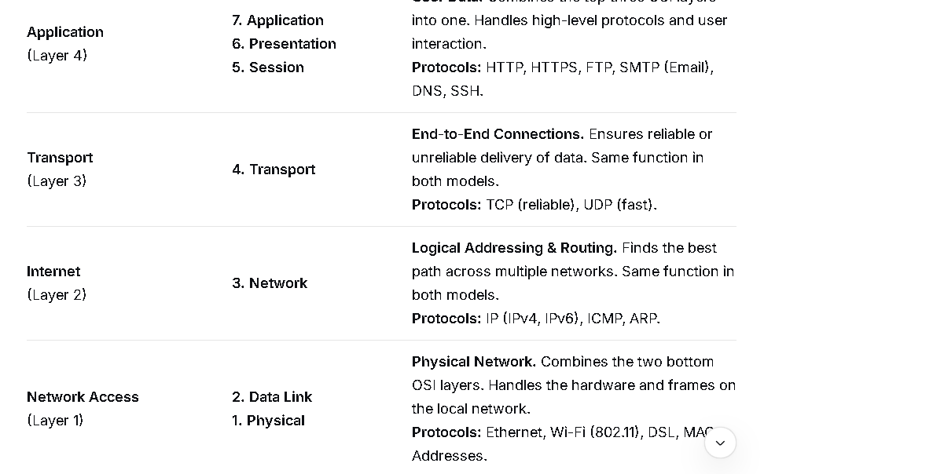

7. What is a DDoS attack and how can an organization like NICL protect itself from one?

What is a DDoS Attack?
A DDoS (Distributed Denial-of-Service) attack is a malicious attempt to disrupt the normal traffic of a targeted server, service, or network by overwhelming it with a flood of internet traffic.
Think of it like this:
- Normal Traffic: A handful of customers entering a shop through a single door, browsing, and making purchases. The door can handle the flow.
- DDoS Attack: Thousands of people (bots) are suddenly sent to block the shop's entrance simultaneously. They don't want to buy anything; they just want to block the door so that legitimate customers cannot get in.
Let's break down the key terms:
- Denial-of-Service (DoS): The goal is to deny you access to a service (e.g., your website, online portal, email).
- Distributed (D): The attack doesn't come from one computer. It comes from thousands or even millions of devices (computers, IoT devices like cameras, routers) distributed globally that have been infected with malware, forming a "botnet." This makes the attack much larger and harder to stop than an attack from a single source.

Implement Robust Network Architecture:
- Redundancy: Have servers and data centers in multiple, geographically separate locations. If one location is under attack, traffic can be failed over to another.
- Load Balancers: Distribute traffic evenly across multiple servers to prevent any single one from being overwhelmed.
- Firewalls & Intrusion Prevention Systems (IPS): Can help block some protocol-based and application-layer attacks, but are often insufficient against large volumetric attacks.
- Continuous Monitoring:
  - Use monitoring tools to establish a baseline of your normal traffic patterns.
  - Set up alerts for unusual traffic spikes, high server resource usage, or a surge in requests from a specific country.

8. Explain the concepts of firewall, VPN, and intrusion detection systems. Why are they essential for a government-owned company?

1. Firewall
Concept: A firewall is a network security device. It monitors and controls incoming and outgoing network traffic based on a set of predefined security rules.
- How it Works: It inspects "packets" of data, looking at their source, destination, and type of content. It then allows or blocks them based on the rules. Firewalls can be:
  - Hardware-based: A physical device at the network perimeter.
  - Software-based: A program running on an individual computer.

2. VPN (Virtual Private Network)
Concept: A VPN creates a secure, encrypted "tunnel" over a public network (like the internet). It allows remote users to securely access a private network as if they were directly connected to it
Imagine the internet is a public highway. When you drive your car (send data) to a website, everyone can see your car (your data), your license plate (your IP address), and where you're going.
Now, imagine a VPN is a private, invisible, armored tunnel that runs directly from your house to your office building.
- You enter the tunnel from your house (you turn on the VPN).
- Your car goes into the tunnel and becomes invisible and armored (your data is encrypted).
- You exit the tunnel directly inside your office building (the VPN server).
- Now, when you go to a website, it's as if you are leaving from the office building, not from your house.
The key points:
- The Internet (Highway) sees the office building's address (the VPN server's IP), not your home address (your real IP).
- The Internet (Highway) cannot see what's inside your car (your data) because it's armored (encrypted).
- The website you visit thinks you are visiting from the office building's location.

Let's Break It Down Step-by-Step

Without a VPN (The Risky Way):
- You (in your home in New York) → "Hi Google, show me google.com"
- Your request travels naked over the public internet.
- Your Internet Provider (ISP) can see you are going to Google.
- Google sees the request came from your home IP in New York.
- Anyone snooping on your public Wi-Fi can potentially see your data.
Result: Your privacy is low. Your location and activity are exposed.

With a VPN (The Secure Way):
- You (in your home in New York) → "Hello VPN, please connect me."
- Your device creates a secure, locked box around all your internet data.
- This locked box is sent to the VPN Server (e.g., in London).
- Your Internet Provider (ISP) only sees a locked box going to the VPN. They can't see what's inside.
- The VPN Server in London unlocks the box and sends the request to Google: "Hi Google, show me google.com."
- Google sees the request came from the VPN server in London. It has no idea you are actually in New York.
Result: Your privacy is high. Your real location is hidden, and your data is encrypted.

Why Do People Use VPNs? The 3 Main Reasons

1. Security on Public Wi-Fi
- Scenario: You're using free Wi-Fi at an airport or coffee shop.
- Danger: These networks are often unsecure. Hackers on the same network can easily "eavesdrop" and steal your passwords, credit card info, and personal data.
- How VPN Helps: The VPN encrypts everything on your device. Even if a hacker intercepts it, all they see is scrambled, unreadable gibberish.

2. Privacy from Your Internet Provider & Others
- Scenario: You don't want your Internet Service Provider (ISP) to track, log, and sell your browsing history.
- How VPN Helps: Your ISP can only see that you are connected to a VPN. They cannot see which websites you visit or what you do on those sites. All your activity is hidden inside the encrypted tunnel.

3. Accessing Geo-Blocked Content
- Scenario: A streaming service (like Netflix) has different movies available in the UK than in the USA. You want to watch a show that's only available in the UK.
- How VPN Helps: You connect to a VPN server located in the UK. Now, the streaming service thinks you are browsing from the UK, so it gives you access to the UK library of movies and TV shows.
A VPN (Virtual Private Network) is a service that creates a secure, encrypted connection over the internet. It hides your IP address and protects your data from snoopers, making your online activity private.

3. Intrusion Detection System (IDS)
Concept: An IDS is a security alarm system for your network or individual computers. It continuously monitors network traffic or system activities for malicious actions or policy violations.
- Analogy: It's like having security cameras and motion sensors inside your building. The cameras don't stop an intruder from entering, but they detect suspicious activity (like a broken window) and sound a loud alarm to alert security personnel.
- How it Works: The IDS analyzes traffic and compares it against a database of known attack signatures or detects anomalies from "normal" behavior. When it finds something suspicious, it generates an alert for a security analyst to investigate.

9. What is the difference between HTTP and HTTPS? Why is HTTPS non-negotiable for customer portals?

The Technical Difference
The core difference is one word: Security.
HTTP (HyperText Transfer Protocol)
- It is the basic, unsecured protocol for transferring data between a web browser and a website.
- All communication is sent in plain text.
- No encryption, no identity verification, and no data integrity checks.
HTTPS (HyperText Transfer Protocol Secure)
- It is the secure version of HTTP.
- It uses SSL/TLS encryption to protect all data exchanged between the browser and the website.
- It provides three vital layers of security:

1. It Protects User Login Credentials
- The Risk with HTTP: When a user types their username and password into an HTTP login page, that information is sent over the internet in plain text. A hacker on the same Wi-Fi network (at a coffee shop, airport, etc.) can easily "sniff" and steal these credentials.
- How HTTPS Helps: It encrypts the login details, making them completely unreadable to anyone intercepting the connection.
How HTTPS Helps: To get an HTTPS certificate (especially an "EV" or "OV" certificate), a business undergoes a validation process by a trusted Certificate Authority (CA).
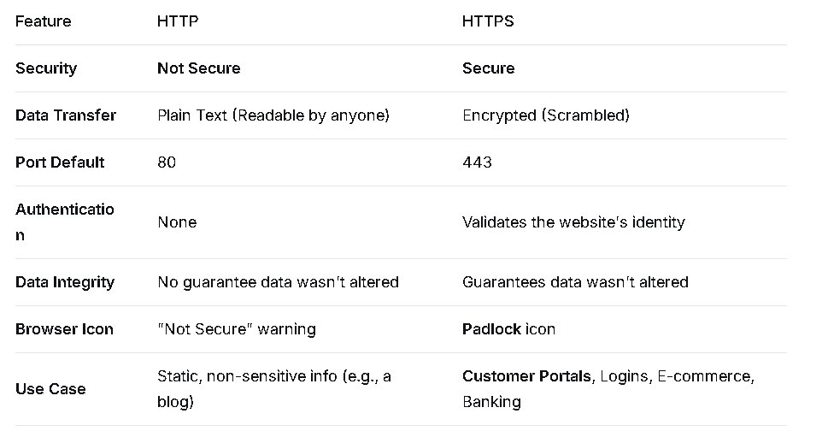
10. What are some common cyber threats facing the BFSI (Banking, Financial Services, and Insurance) sector today?

1. Phishing and Social Engineering (The Human Firewall)
- What it is: Deceptive emails, text messages (smishing), or phone calls (vishing) designed to trick employees or customers into revealing login credentials, personal information, or installing malware.
- BFSI Impact: This is the primary entry point for most attacks. A single employee clicking a malicious link can lead to a massive network breach. Customers tricked by fake bank websites lead to direct financial loss and identity theft.
- Example: A sophisticated "spear-phishing" email targeting a bank manager, appearing to be from the CEO, urgently requesting a wire transfer to a fraudulent account.

2. Ransomware & Data Extortion
- What it is: Malware that encrypts a victim's files, making systems unusable until a ransom is paid. Modern variants now also steal data before encrypting it, threatening to leak it online ("double extortion").
- BFSI Impact: A successful attack can freeze core banking operations, halt trading, and disable ATMs, causing immense financial and reputational damage. The incentive to pay the ransom is extremely high to restore services quickly.
- Example: The 2021 attack on Ireland's Health Service Executive (HSE) is a classic case, though not BFSI, showing the disruption. A similar attack on a bank could paralyze its entire operation.

3. API Security Vulnerabilities.
- What is: The BFSI sector is rapidly adopting Open Banking, which relies on Application Programming Interfaces (APIs) to share data between banks and third-party fintech apps. Insecure APIs can be exploited to access vast amounts of customer data.

Distributed Denial-of-Service (DDoS) Attacks
- What it is: Overwhelming a bank's online services (website, mobile app, online banking portal) with a flood of fake traffic, making them unavailable to legitimate customers.

Deepfakes and AI-Powered Fraud
Using Artificial Intelligence (AI) to create highly realistic but fake audio or video content.
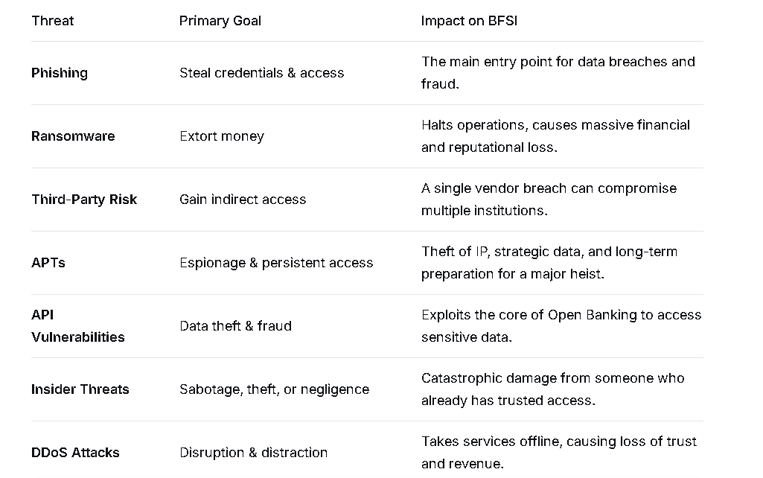
C) Programming & Software Development:
11. What is the difference between Object-Oriented Programming (OOP) and Procedural Programming?

"Sir/Ma'am, Object-Oriented Programming (OOP) and Procedural Programming are two fundamental paradigms for structuring code. The core difference lies in how they organize data and the procedures that operate on that data.
Let's break it down with a simple analogy:
- Procedural Programming is like a traditional kitchen. You have data (ingredients) laid out on the counter, and you have procedures (chefs with recipes) that come over, take the ingredients, process them, and produce a dish. The data and the procedures that act on it are separate.
- Object-Oriented Programming is like a modern, organized kitchen with specialized stations. Each station (an object) has its own ingredients (data) and its own tools and recipes (procedures/methods) bundled together. The Pizza Station has its own dough, sauce, and cheese, and it knows how to make a pizza. You don't take the sauce to the baking station; you just tell the Pizza Station to "make a pizza."
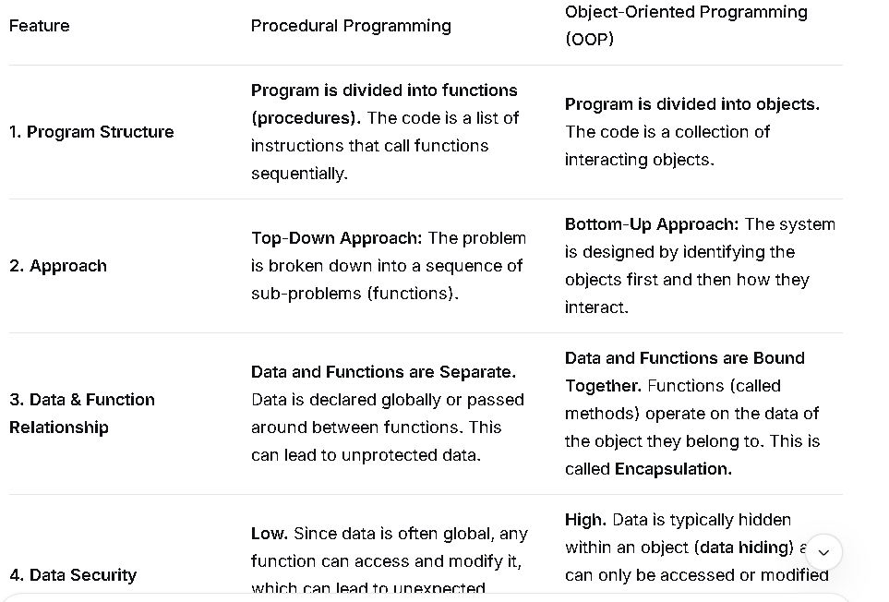
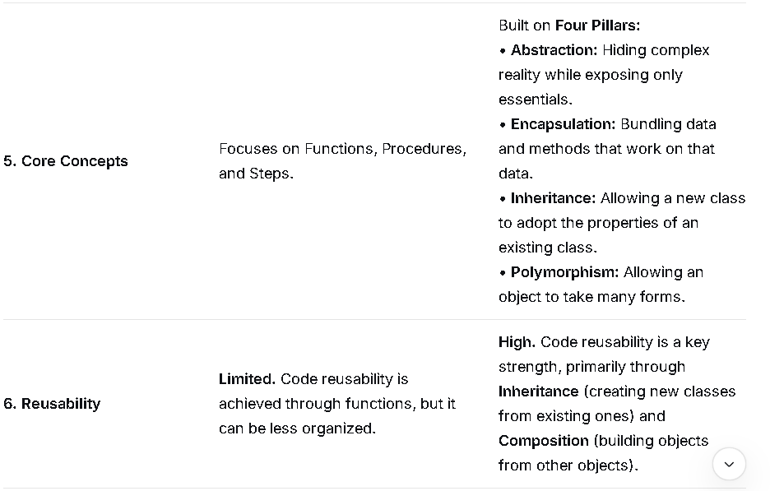
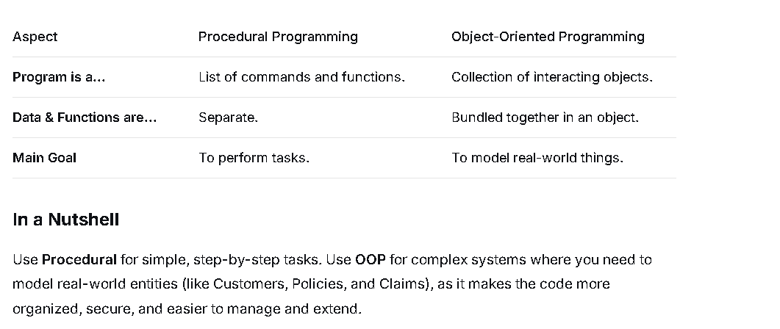

Procedural Programming (POP)
Procedural programming is a programming paradigm that focuses on procedures (also known as functions or subroutines) that perform computations. It is primarily about how a program accomplishes its goal by breaking the task down into a sequence of steps.

Key Concepts
- Focus on Procedures: The program is divided into smaller, manageable routines or functions. The main program calls these procedures in a specific order to execute the task.
- Data and Functions are Separate: Data structures are generally defined separately from the functions that operate on them. Data is often shared globally or passed explicitly between functions.
- Top-Down Design: The design starts with the main function and breaks it down into smaller and smaller sub-functions. This is often called functional decomposition.
- Examples: Languages like C, Pascal, FORTRAN, and BASIC.

Analogy
Imagine writing a recipe. Procedural programming is like listing the steps to follow in order: Take 1 cup of flour, Add 2 eggs, Mix ingredients, Bake for 30 minutes, etc. The focus is on the sequence of actions.

🧱 Object-Oriented Programming (OOP)
Object-Oriented Programming is a programming paradigm that focuses on objects, which are instances of a class. It models a system as a collection of interacting objects, where each object bundles data and the functions that operate on that data. It is primarily about what entities exist and how they relate.

Key Concepts (The Four Pillars)
- Encapsulation: Bundling data (attributes/properties) and the methods (functions/behavior) that operate on the data into a single unit (the object). It also involves hiding the internal state of an object from the outside world.
- Inheritance: Allows a new class (subclass) to inherit the properties and methods of an existing class (superclass), promoting code reuse.
- Abstraction: Hiding complex implementation details and showing only the essential information to the user.
- Polymorphism: The ability of different objects to respond to the same message or method call in different ways.
- Focus on Objects and Classes: Programs are built around objects that represent real-world entities. Objects are created from classes, which act as blueprints.
- Data and Functions are Together: Data (attributes) and the procedures (methods) that manipulate that data are tightly linked within the object.
- Bottom-Up Design: The design starts with defining the objects and their interactions, building up to the complete system.
- Examples: Languages like Java, C++, Python, C#, and Ruby.

Analogy
Imagine the same recipe, but using OOP. You would define a Mixer object (with data like speed and methods like startMixing), a Oven object (with data like temperature and methods like heatUp), and a Cake object (with data like ingredients and bakeTime). The program then consists of these objects interacting.

1. Procedural Programming (POP)
- Focus: The program is a list of steps, or procedures (functions), that tell the computer how to do a task.
- Analogy: A To-Do List. You follow the steps one by one.
- Key: Data and the functions that use the data are kept separate.

2. Object-Oriented Programming (OOP)
- Focus: The program is a collection of objects (like digital things), where each object bundles its own data and the functions that only work on that data.
- Analogy: A Team. Each team member (object) has their own gear (data) and specific skills (functions) they use with that gear.
- Key: Data and functions are bundled together (Encapsulation). This makes large programs more organized and reusable.

In the end:
- POP is about breaking a task into steps.
- OOP is about breaking the world into objects.
Do you have a favorite programming language you'd like to know if it's POP or OOP?

12. Explain the Software Development Life Cycle (SDLC) and its various models (e.g., Waterfall, Agile). Which model do you think is most suitable for developing a new insurance policy management system and why?

What is the Software Development Life Cycle (SDLC)?
The Software Development Life Cycle (SDLC) is a structured process for building software that aims to produce high-quality, cost-effective software in the shortest possible time. It provides a framework of phases, deliverables, and milestones that guide developers, project managers, and stakeholders from the initial idea to the final deployment and maintenance of the software.
The core phases of a typical SDLC are:
- Planning & Requirement Analysis: Defining the project's goals, scope, feasibility, and resource requirements. Key stakeholders collaborate to gather and document what the software must do.
- System Design: Creating the architectural blueprint for the software. This includes defining hardware, system architecture, databases, user interfaces, and other components.
- Implementation (Coding): Developers write code according to the design specifications. This is the phase where the software is actually built.
- Testing: The software is rigorously tested to identify and fix bugs, ensure it meets the requirements, and performs as expected.
- Deployment: The finished product is released to the production environment for users.
- Maintenance: After deployment, the software requires ongoing support, bug fixes, updates, and potential new features to adapt to changing needs.

Key SDLC Models
Different projects require different approaches. Here are the most common SDLC models:

1. Waterfall Model
This is a linear and sequential approach. Each phase must be fully completed before the next one begins. There is no overlapping or going back.
- Pros: Simple to understand and manage; clear milestones; good for projects with well-defined, stable requirements.
- Cons: Inflexible; late working model; costly and difficult to make changes after a phase is complete; high risk of not meeting user needs if requirements were misunderstood initially.
Analogy: Building a house. You complete the architectural plans (Design), then pour the foundation (Implementation), then build the frame, etc. You can't easily go back and change the foundation once the walls are up.

2. Agile Model
Agile is an iterative and incremental approach. The project is broken down into small cycles (called "Sprints," typically 2-4 weeks long). Each sprint results in a working, tested piece of software. Requirements evolve through collaboration between self-organizing, cross-functional teams.
- Pros: Highly adaptable to changing requirements; delivers working software frequently; encourages continuous customer feedback; higher customer satisfaction.
- Cons: Can be less predictable; requires a high level of customer involvement; the lack of extensive initial documentation can be a risk if team members leave.
Analogy: Sculpting a statue. You start with a rough shape and refine it iteratively based on continuous feedback, rather than carving the final details from a single, unchangeable blueprint

13. What is version control, and what are its benefits? Have you worked with Git?
Version Control is a system that saves every change you make to your project files. It lets you track your work history and undo any mistakes easily. It also lets multiple people work on the same project together without overwriting each other's changes.
At its core, a Version Control System (VCS) manages three key things:
- Changes: What was changed?
- Author: Who changed it?
- Timestamp: When was it changed?

What are its Benefits?
The benefits of using a version control system are massive, especially for collaborative work.
- Complete History & Change Tracking:
  - See every single change made to the project, line by line.
  - Understand why a change was made by linking it to a commit message (e.g., "Fixed the login bug" or "Added user profile feature").
- Branching and Merging:
  - Branching: You can create isolated "copies" of your project (called branches) to work on new features or bug fixes without affecting the main, stable version.
  - Merging: Once the work on your branch is tested and ready, you can cleanly integrate it back into the main branch.
- Collaboration and Teamwork:
  - Multiple developers can work on the same project simultaneously without overwriting each other's work. The VCS manages the integration of changes.
- Undo Mistakes & Rollback to Stable States:
  - Made a breaking change? You can easily revert your project back to a previous, working state. This is a lifesaver and reduces a huge amount of stress.
- Backup and Disaster Recovery:
  - A version control system like Git stores the entire project history in a repository. Every developer who "clones" the repository has a full backup of the project and its entire history.
- Traceability:
  - If a bug is introduced, you can use tools like git bisect to quickly find the exact change that caused the problem.

14. What is API? Can you explain REST API and why it's so widely used?

What is an API?
An API (Application Programming Interface) is a set of rules, protocols, and tools that allows different software applications to talk to each other.
A simple, real-world analogy is a waiter in a restaurant:
- You (the customer) are one application (like a mobile app).
- The Kitchen is another application (like a server or database).
- The Waiter is the API.
You don't go into the kitchen to prepare your meal. Instead, you give your order (a request) to the waiter, who understands it, relays it to the kitchen, and then brings your food (the response) back to you. The API acts as this intermediary, defining exactly how you can make a request and what kind of response you can expect.
In technical terms, an API is a contract between two systems: "If you send me a request in this specific format, I promise to send you back a response in that specific format."

What is a REST API?
REST (Representational State Transfer) is an architectural style and set of constraints for building APIs. It's not a protocol or standard, but a set of design principles. An API that follows these principles is called a RESTful API.
The key constraints of REST are:
- Stateless: Each request from a client to a server must contain all the information the server needs to understand and process the request. The server doesn't store any session data about the client between requests.
- Client-Server: There's a clear separation between the client (e.g., a web browser or mobile app) and the server (where the data and logic live). This allows them to evolve independently.
- Uniform Interface: This simplifies the architecture. The most common way to achieve this is by using:

15. What is the importance of testing? Differentiate between unit testing, integration testing, and user acceptance testing (UAT).

The Importance of Testing
Testing is not just about finding bugs; it's a comprehensive quality assurance activity that serves multiple vital purposes:
- Uncover Defects (Bugs): This is the most obvious goal. Testing identifies errors, gaps, or missing requirements in the software before it reaches the end-user.
- Ensure Software Quality & Reliability: It verifies that the software is fit for its intended purpose, works as expected, and is stable under various conditions. This builds user trust.
- Reduce Development Costs: Fixing a bug in the early stages (e.g., during coding) is exponentially cheaper than fixing it after deployment, where it can cause system failures, data corruption, and expensive hotfixes.
- Ensure Security: Security testing helps uncover vulnerabilities that could be exploited by malicious actors, protecting sensitive user data and system integrity. This is especially crucial for systems like the insurance policy management system we discussed, which handles personal and financial data.
- Validate Business Requirements: Testing confirms that the software being built actually meets the business needs and requirements it was designed for.
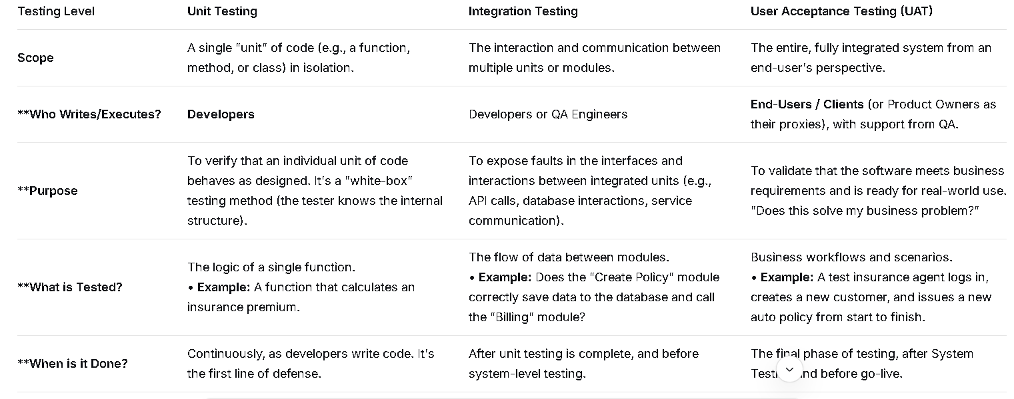

16. Compare Windows Server and Linux. In what scenarios might you prefer one over the other for NICL's backend servers?
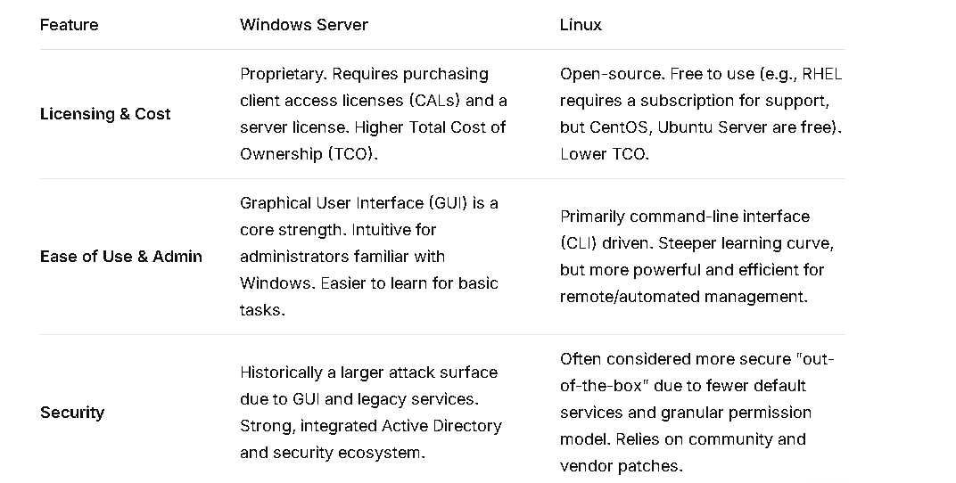
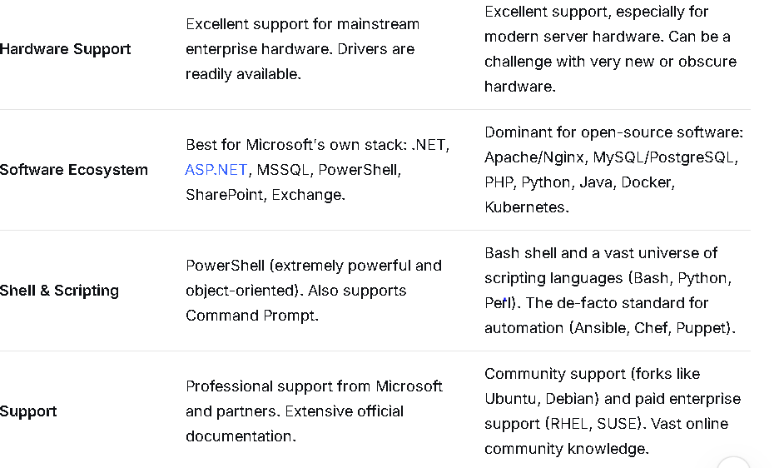
17. What is cloud computing (IaaS, PaaS, SaaS)? What are the potential benefits and risks of migrating NICL's infrastructure to the cloud?

1. What is Cloud Computing? (IaaS, PaaS, SaaS)
Cloud computing is the on-demand delivery of IT resources and applications over the Internet with pay-as-you-go pricing. Instead of owning and maintaining physical data centers and servers, you can access technology services.
The three main service models are best understood as a stack:
IaaS (Infrastructure as a Service)
- What you get: The fundamental building blocks of computing: virtual machines, storage, networks, and operating systems.
- You Manage: The OS, runtime, middleware, and applications.
- Vendor Manages: Physical servers, hypervisors, storage, and networking.
- Analogy: Renting a plot of land. You can build whatever you want, but you're responsible for the building, utilities, and maintenance.
- Examples: Amazon Web Services (AWS) EC2, Microsoft Azure VMs, Google Compute Engine.
PaaS (Platform as a Service)
- What you get: A platform allowing you to develop, run, and manage applications without the complexity of building and maintaining the underlying infrastructure.
- You Manage: The applications and data.
- Vendor Manages: Runtime, middleware, OS, virtualization, servers, storage, networking.
- Analogy: Renting a fully furnished apartment. You can live in it and decorate, but you don't worry about plumbing, electricity, or the building's structure.
- Examples: Google App Engine, Microsoft Azure App Service, Heroku.
SaaS (Software as a Service)
- What you get: A complete, cloud-hosted software application that you use over the internet.
- You Manage: Nothing. Just your data and user settings.
- Vendor Manages: Everything from the application down to the physical infrastructure.
- Analogy: Staying in a hotel. You just use the room and its amenities; the hotel manages everything else.
- Examples: Gmail, Microsoft Office 365, Salesforce, SAP S/4HANA Cloud.

2. Potential Benefits of Migrating NICL's Infrastructure to the Cloud
For a public sector insurance company like NICL, the benefits are transformative:
- Significant Cost Reduction & Shift from Capex to Opex:
  - Eliminates Upfront Capital Expenditure (Capex): No need to purchase expensive hardware, software, or data center space.
  - Pay-Per-Use Model (Opex): NICL would only pay for the computing resources it actually uses. This is ideal for handling variable workloads, like end-of-month processing or new policy drives.
- Enhanced Scalability and Agility:
  - Instant Scalability: During high-demand periods (e.g., after a natural disaster when claims surge), NICL can instantly scale up its computing power to process claims faster. It can then scale down when demand normalizes.
  - Faster Innovation: Developers can spin up new environments in minutes to test new insurance products or digital services, drastically reducing time-to-market.
- Improved Business Continuity and Disaster Recovery (BCDR):
  - Built-in Redundancy: Cloud providers have data centers distributed globally. NICL's data and applications can be replicated across multiple geographic locations, ensuring operational resilience even if one location fails.
  - Robust Backup Solutions: Automated, cost-effective backup and recovery tools are native to cloud platforms, protecting against data loss.
- Strengthened Security and Compliance:
  - Advanced Security Infrastructure: Cloud providers invest billions in security, offering capabilities that are difficult for a single organization to match (e.g., advanced threat detection, DDoS protection, encryption).
  - Compliance Certifications: Major cloud providers adhere to a wide range of global and industry-specific compliance standards (e.g., ISO, SOC, GDPR), which can help NICL meet regulatory requirements more easily.
- Enablement of Digital Services:
  - The cloud is the foundation for modern technologies like AI/ML, data analytics, and IoT. NICL could leverage these for fraud detection, personalized insurance products, and risk assessment.

3. Potential Risks and Challenges for NICL
The migration must be carefully managed to mitigate these risks:
- Data Security and Privacy Concerns:
  - Sensitive Data: Insurance companies handle vast amounts of highly sensitive personal and financial data (PII). Storing this off-premises requires absolute trust in the cloud provider's security controls and a clear understanding of the shared responsibility model.
  - Data Sovereignty: NICL must ensure that data is stored and processed in geographic locations that comply with national data protection laws (e.g., within India).
- Compliance and Regulatory Hurdles:
  - As a public sector entity, NICL is subject to strict government regulations (e.g., from IRDAI). Gaining approval for cloud adoption and ensuring the chosen provider and architecture meet all regulatory guidelines can be a complex and lengthy process.
- Migration Complexity and Cost Overruns:
  - Legacy Application Challenges: NICL likely has older, monolithic applications that are not designed for the cloud. Refactoring or replacing them can be expensive, time-consuming, and risky.
  - Unexpected Costs: Without careful planning and governance ("cloud cost optimization"), pay-per-use can lead to bill shock if resources are not properly managed and monitored.
- Vendor Lock-in:
  - Becoming heavily dependent on a single cloud provider's proprietary technologies and services can make it difficult and costly to switch providers or move back on-premises in the future.
- Connectivity Dependency:
  - Cloud services require a reliable, high-speed internet connection. Any network outage would disrupt operations, impacting customer service and internal processes.

Conclusion
For NICL, migrating to the cloud is not a question of if but how. The potential benefits in cost savings, operational resilience, and innovation are too significant to ignore. However, the journey must be strategic.
A recommended approach would be a phased migration, starting with less critical applications and a hybrid cloud model (keeping some sensitive systems on-premises while leveraging the cloud for others). This allows NICL to build internal expertise, manage risks effectively, and realize value incrementally while ensuring national and regulatory compliance.
18. What is virtualization? How is it different from containerization (e.g., Docker)?
19. What is RAID and what are its different levels? Why is it used in server environments?

Category 2: IT in the Insurance Domain (Domain-Specific)
This is crucial. It shows you understand why the technology is needed.
- How can technology be used to detect and prevent insurance fraud? (Think AI/ML, data analytics).

What is Insurance Fraud?
First, let's understand the problem. Insurance fraud is when people lie to an insurance company to get money they don't deserve.
- Example 1: Someone stages a car crash or claims their TV was "stolen" when it actually broke.
- Example 2: A criminal ring sets up fake clinics and lawyers to bill for accidents that never happened.

How Technology Catches the Bad Guys
Think of the insurance company's technology like a super-smart detective that never sleeps.
1. It Spots Weird Patterns (Data Analytics)
- The "Too Many Coincidences" Alarm: The system notices if the same doctor, lawyer, and repair shop are involved in dozens of different "accidents." It connects the dots that a human might miss.
- The "This Seems Fishy" Flag: If you just bought a policy yesterday and have a huge claim today, that's a red flag. The system compares your claim to millions of others to see if it stands out as strange.
2. It Learns from the Past (Machine Learning - ML)
This is the really smart part. The system learns from all the fraud that's been caught before.
- It's Like a Student: The company shows the computer thousands of past claims and says, "These were fake, and these were real." The computer learns the hidden tricks and patterns of a fake claim.
- The Fraud Score: When a new claim comes in, the computer instantly gives it a "fraud score" (like 1% to 100%). A low score means it looks honest. A high score means, "Stop! This needs a closer look!"
3. It Sees and Hears Everything (AI)
- Photo Detective: If you send a photo of your damaged car, the AI can tell if the photo was edited or if it's actually a picture you downloaded from the internet.
- Story Checker: When you describe what happened, the system can read your words and compare them to other stories. If your story has the same strange wording as known fake claims, it gets flagged.

- What key features would you include in a mobile app for NICL policyholders?

. Digital Insurance ID Card
- What it is: A digital version of your policy documents, stored right in the app.
- Why it's key: No more worrying about forgetting paperwork. During a traffic check or at a hospital, you can instantly show proof of insurance. It can include a QR code for quick verification.

2. One-Touch Claim Intimation & Tracking
- What it is: A simple, guided process to report a claim directly from your phone.
- Why it's key:
  - Easy Reporting: Use your phone to instantly notify NICL about a claim. You can fill in details, take and upload photos of the damage, and even e-sign forms.
  - Live Tracking: After submitting, track your claim's status in real-time (e.g., "Received," "Surveyor Assigned," "Under Approval," "Payment Processed"). This eliminates anxiety and endless phone calls.

3. Policy Management & Renewal
- What it is: A single dashboard for all your policies with NICL.
- Why it's key:
  - View All Policies: See your health, motor, home, etc., policies in one place.
  - Download Documents: Instantly download your policy wording, certificate, and renewal notices.
  - One-Click Renewal: Get reminders and renew your policies securely within the app in just a few taps, without any agent or paperwork.

4. Premium Calculator & Policy Purchase
- What it is: Tools to explore and buy new insurance directly from the app.
- Why it's key: If you need a new travel insurance policy or want to insure a new car, you can compare plans, calculate your premium, and purchase the policy instantly, 24/7.

5. Cashless Hospital Locator & Request
- What it is: An interactive map to find nearby hospitals that have a cashless agreement with NICL.
- Why it's key: In a medical emergency, you can quickly find a network hospital and even submit a pre-authorization request for cashless treatment directly through the app, reducing financial stress.

6. Secure In-App Messaging & Support
- What it is: A direct and secure chat channel to communicate with NICL customer support or your dedicated agent.
- Why it's key: Get quick answers to your questions without calling a helpline. All conversations are saved in the app for future reference.

In Simple Terms:
Think of the app as a "Pocket-Sized NICL Office" that gives you:
- Your Documents: Always in your pocket.
- Claim Help: Report and track claims easily, like tracking a food delivery.
- Easy Payments & Renewals: Manage your policies as easily as your online shopping.
- Emergency Help: Find hospitals and get support when you need it most.

- How can Business Intelligence (BI) and Data Analytics help an insurance company in pricing policies, understanding customer behavior, and managing risk?

Pricing Policies: From "One-Size-Fits-All" to "Personalized & Fair"
The old way was to group people into broad categories (e.g., "all 30-year-old male drivers"). Now, pricing can be far more precise.
- Risk-Based Pricing (Telematics): For auto insurance, instead of just using age and car model, companies can use data from a telematics device or mobile app. They can analyze your actual driving behavior—how fast you drive, how hard you brake, what time of day you drive—to create a personalized premium that truly reflects your risk.
- Predictive Modeling: By analyzing historical data, insurers can identify subtle risk factors. For example, they might find that a combination of a person's credit score, occupation, and even their online behavior patterns correlates with lower claim frequency.
- Fraud Detection (as discussed earlier): This is a huge part of risk management. Advanced analytics can detect complex fraud rings and suspicious claim patterns that humans would miss, saving the company millions.
- Churn Prediction: By analyzing patterns in customer data (e.g., late payments, frequent calls to complain, not responding to renewal notices), analytics can flag customers who are likely to leave. This allows the company to proactively intervene with a retention offer or improved service before it's too late.

- What are the specific IT challenges a large, legacy-driven public sector company like NICL might face compared to a new-age private insurer?

Specific IT Challenges for NICL (and similar public sector companies):

1. The Monolithic Legacy Core Systems
- Challenge: NICL likely runs on a very old, monolithic Policy Administration System (PAS), possibly built on outdated languages (like COBOL) and databases. This system is the "heart" of all operations but is extremely rigid and hard to change.
- Comparison: A new-age insurer uses modern, modular, cloud-native core systems (often called "Insurance SaaS") that are designed to be updated and configured easily.
- Impact on NICL: Even a simple product change or regulatory update can take months of work, requiring highly specialized (and aging) programmers. This makes the company slow to react to market changes.
- Challenge: Connecting the old legacy core to new, modern systems (like a new mobile app or a CRM) is incredibly complex and expensive. It requires custom-built "middleware" and APIs that are fragile and hard to maintain.

Cultural and Skill Gap
- Challenge: The IT workforce in a public sector company may be skilled in maintaining legacy systems but lacks experience in agile methodologies, cloud computing, DevOps, and data science.

Regulatory and Procurement Hurdles
- Challenge: As a public sector entity, NICL is subject to stringent government procurement rules. Buying a new software system isn't a quick decision; it involves long tendering processes and a focus on lowest-cost bidding, which may not yield the best technology solution.

- How can IT improve the claim settlement process, making it faster and more transparent for the customer?
The goal is to move from a paper-based, manual workflow to a digital, automated, and customer-centric journey.
Here’s how IT makes this happen, focusing on speed and transparency:

How IT Makes Claims Faster
1. Digital First Notice of Loss (FNOL):
- How it works: Instead of calling a call center and waiting on hold, customers can report a claim 24/7 through a mobile app or website. They can fill out details, upload photos/videos of the damage, and even use their phone's camera to scan documents.
- Speed Gain: Eliminates call center queues and data entry delays. The claim is created instantly in the system.
2. AI-Powered Triage and Automation:
- How it works: As soon as a claim is submitted, an AI system automatically assesses it.
  - Simple Claims: For minor, low-risk claims (e.g., a cracked windshield, a minor phone screen damage), the system can auto-approve and initiate payment instantly, with no human intervention. This is often called "straight-through processing."
Integration with Ecosystem Partners:
- How it works: The insurer's system is digitally connected to networks of repair shops, rental car companies, and hospitals.

How IT Makes Claims More Transparent
1. Real-Time Claim Tracking Dashboard:
- How it works: Think of it like "tracking your pizza delivery" but for your insurance claim. The mobile app or customer portal shows a visual status bar with clear stages:
  - Claim Received → Surveyor Assigned → Assessment Complete → Approved → Payment Sent.
Proactive SMS/App Notifications:
- How it works: The system automatically sends proactive updates at every key milestone.
  - SMS Example: "Hi [Name], your claim #12345 has been approved. Payment of ₹15,000 will be processed within 24 hours."
Chatbots and In-App Messaging:
- How it works: For any questions, the customer can use a secure chat function within the app to get instant answers about their claim status, document requirements, or policy coverage.
Digital Documentation and Image Analytics:
- How it works: Customers upload photos and documents directly through the app. AI can analyze these images to estimate damage and verify the claim. All documents are stored digitally in one place.

- What is the importance of "Insurance Repository" and how does IT facilitate it?

What is an Insurance Repository? (The "Digital Locker" for Insurance)
Imagine you have multiple insurance policies—one for life, one for health, one for your car—from different companies. Traditionally, you would have a separate paper document for each policy, which can be easily lost or damaged.
An Insurance Repository is like a secure, digital locker for all your insurance policies.
- It is an entity that is licensed by the insurance regulator (like IRDAI in India) to convert your physical insurance policies into an electronic form (e-dematerialization).
- Instead of multiple paper documents, you get a single e-Insurance Account (eIA).
- All your policies, from any insurer, are held securely in this one digital account.

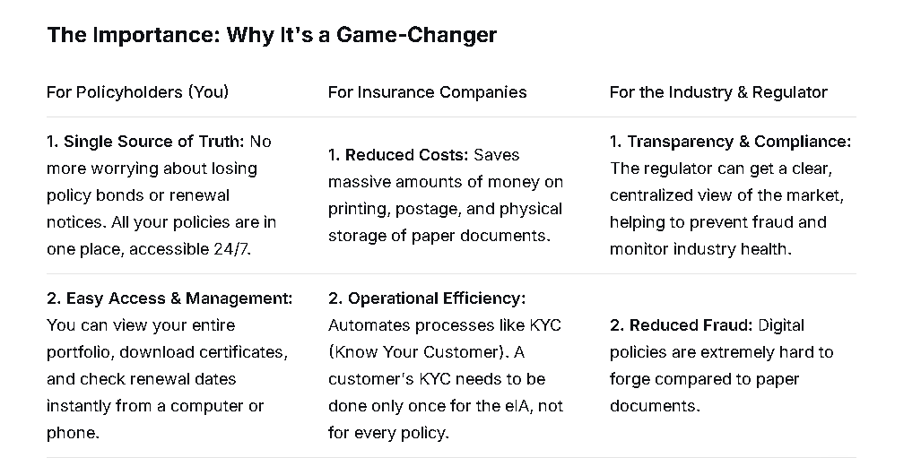
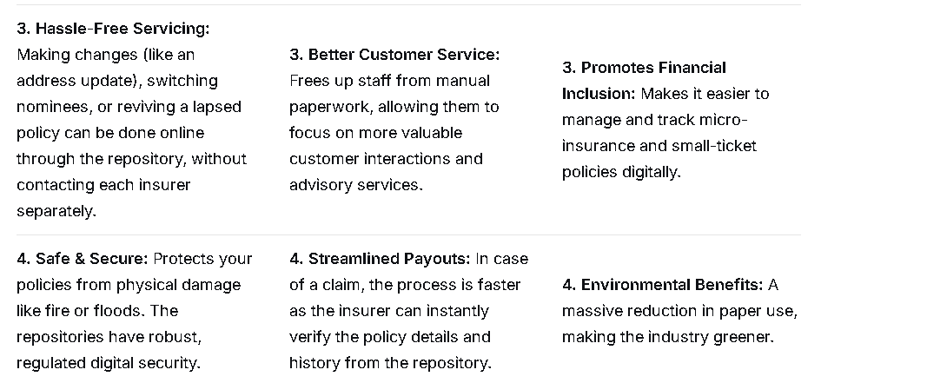

Category 3: Behavioral and Situational Questions
These assess your soft skills, problem-solving ability, and attitude.
- Tell us about a time you had to explain a complex technical problem to a non-technical person (like a senior manager).
- Describe a situation where a project you were working on had a tight deadline. How did you manage your time and priorities to ensure delivery?
- Tell us about a time you made a mistake in a technical task. How did you identify it, and what did you do to rectify it?
- Imagine you propose a new, more efficient software system, but your team is resistant to change. How would you handle this situation?
- How do you stay updated with the latest trends and technologies in the IT field?
- Why did you choose to apply for an IT role in a public sector insurance company like NICL, instead of a tech giant or a startup?

Category 4: Current Affairs & Industry Awareness
This tests your awareness of the broader context.
- What are your views on "Bima Sugam" and how will it impact the insurance industry?
- How is IRDAI promoting the use of technology in the insurance sector (e.g., "Insurtech")?
- What is the role of Aadhaar and e-KYC in simplifying insurance onboarding?
- How can technologies like Blockchain be leveraged in the insurance sector?
- What are the challenges and opportunities of implementing AI in a government organization like NICL?

Category 5: Questions Specific to NICL
This shows you've done your homework.
- What do you know about NICL? What are its strengths and weaknesses from an IT perspective?
- The insurance sector is highly competitive. How can NICL's IT department help it gain a competitive edge?
- How can technology help NICL in achieving its social and rural sector obligations?

How to Prepare for the Interview:
- Revise Your Basics: Don't just read definitions. Understand the "why" behind every concept.
- Connect Tech to Domain: For every technical concept, think of its application in the insurance world.
- Prepare Your Stories: For behavioral questions, have 3-4 strong stories from your academic projects or past work experience ready using the STAR (Situation, Task, Action, Result) method.
- Stay Updated: Read about recent news related to NICL, IRDAI regulations, and tech trends in insurance.
- Ask Insightful Questions: At the end, you will be given a chance to ask questions. Prepare 2-3 intelligent ones, such as:
  - "What is the current roadmap for the digital transformation of NICL?"
  - "What are the biggest IT challenges the organization is currently facing?"
  - "How does the IT team collaborate with other business verticals like underwriting and claims?"
By preparing across these categories, you will present yourself as a well-rounded candidate who is not only technically sound but also a great fit for the specific role at NICL. Good luck

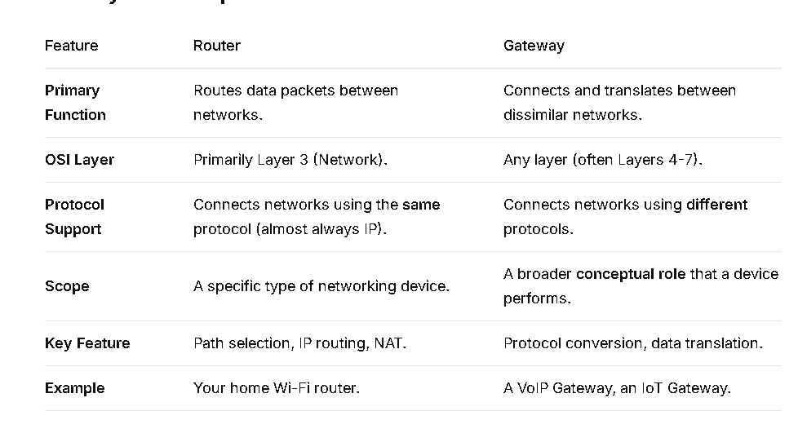
dural
Firmware is a specific type of software that is permanently stored on a hardware device.
Think of it as the "built-in intelligence" that tells the hardware how to function at the most basic level.

A scripting language is a type of programming language that is used to automate tasks, control other software, or glue together different components of a system.
The key idea is that scripts are often written for a runtime environment that interprets and executes the code directly, rather than compiling it into a standalone machine-level executable.

What is a Scripting Language? (The Super Simple Version)
Imagine you have a smart but literal robot friend. You can't just tell it "make breakfast." You have to give it a detailed, step-by-step list of commands:
- Walk to the kitchen.
- Open the fridge.
- Pick up the eggs.
- Turn on the stove.
- Crack eggs into a pan.
- ...and so on.
A script is exactly that: a list of commands written in a language the computer (the robot) understands. A scripting language is the specific set of words and grammar rules you use to write that list.

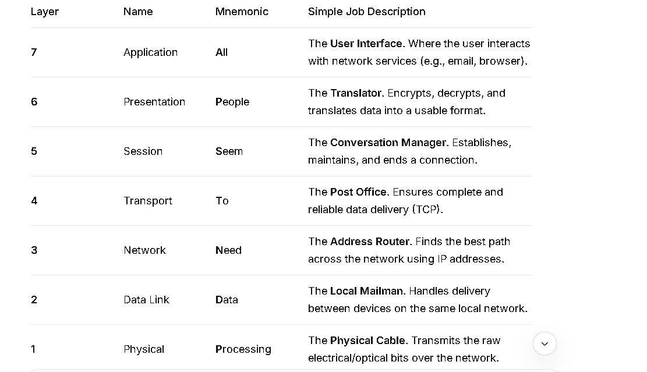

Detailed Breakdown (Using an Email Example)
Let's trace what happens when you send an email.

Layer 7: Application Layer
- What it does: This is the application you see and use (e.g., Gmail, Outlook). It provides the services directly to the user.
- In our example: You typing the email, clicking "Format," and hitting Send happens here.
- Protocols: HTTP, SMTP (for email), FTP.

Layer 6: Presentation Layer
- What it does: It acts as a translator. It ensures the data from the application layer is in a format the receiving computer can understand. It also handles encryption and compression.
- In our example: It might encrypt your email for security or compress a large attachment.
- Think of it as: Converting a .docx file to a PDF so anyone can open it.

Layer 5: Session Layer
- What it does: It establishes, manages, and terminates the "session" or connection between the two computers. It controls the dialogue (who talks when, for how long).
- In our example: It makes the connection to the Gmail server, keeps it alive while you send the email, and then closes it when the transfer is complete.
- Think of it as: The phone operator who sets up the call, keeps the line open, and hangs up when you're done.

Layer 4: Transport Layer
- What it does: This is a critical layer. It takes the data from the session layer and breaks it into smaller pieces called segments. It ensures the reliable delivery of all segments.
- Key Functions:
  - Flow Control: Ensures the sender doesn't overwhelm the receiver.
  - Error Control: Uses acknowledgements to make sure all segments arrived. If one is lost, it asks for a retransmission (this is what TCP does).
- In our example: It breaks your email into manageable packets and assigns a sequence number to each. It then waits for the receiving server to say, "I got packet 1, I got packet 2..."
- Protocols: TCP (reliable), UDP (fast, but not reliable).

Layer 3: Network Layer
- What it does: This layer is all about logical addressing and path selection. It takes the segments from the transport layer and packages them into packets. It then uses the IP Address to find the best route to send the packets from your network to the destination network, potentially across the entire internet.
- In our example: It puts the destination IP address (Gmail's server address) on the packet and figures out the best path through all the routers on the internet to get it there.
- Devices: Routers operate at this layer.
- Protocols: IP (IPv4, IPv6).

Layer 2: Data Link Layer
- What it does: This layer is responsible for moving data within the same local network (e.g., between your computer and your router). It takes packets from the network layer and packages them into frames. It uses physical (MAC) addresses.
- Key Function: It uses MAC addresses to deliver the frame to the correct device on the local network (e.g., from your laptop to your home router).
- In our example: Your computer creates a frame with your router's MAC address and puts the IP packet inside it.
- Devices: Switches operate at this layer.

Layer 1: Physical Layer
- What it does: This is the actual physical hardware. It converts the digital bits (1s and 0s) of the frame into electrical signals, light pulses (fiber), or radio waves (Wi-Fi) and transmits them over the physical medium.
- In our example: The network card in your computer converts the frame into electrical signals that travel over the Ethernet cable or as Wi-Fi radio waves to your router.
- Devices: Cables, hubs, network adapters.

My Job respnsibility.
"My core responsibility is to manage and scale our network capacity to handle growing user demand. I strategically plan, design, and deliver the connectivity for all new 4G, 5G, and AirFiber nodes. This involves integrating new hardware into our existing infrastructure, designing the physical and logical connections, and assigning all necessary IP addresses and UE Pool.Then we have to do testing to ensure every new node and end-user device is seamlessly accessible from the moment they go live."

Detailed & Structured Version (Explains the step-by-step process)
"When user demand increases in a specific location, my role is to design and implement the solution that expands our service capacity. I own the end-to-end process of bringing new network nodes online.
My work follows a clear, strategic process:
- Physical Integration & P2P Planning: First, I plan how the new servers and nodes will physically connect within our data center racks. I design how they link to the network switches and create detailed Point-to-Point (P2P) connection plans. This ensures the physical backbone for communication is robust and correctly mapped.
- Logical Addressing & IP Design: Next, I plan the logical layer. I assign all the necessary IP addresses—both for the infrastructure nodes themselves so we can manage them, and large pools of IPs for User Equipment (UE Pools) so that customers' phones and devices can get online. My design ensures that every element is easily reachable and accessible for network operations.
- Service Migration: A critical part of my role also involves managing connectivity for customer migrations. When we need to move users from an old server to a new one to balance load or upgrade capacity, I plan and execute the connectivity changes to ensure a smooth transition with minimal to no impact on their service.
In essence, I bridge the gap between new hardware and live service, ensuring that our network expansion is smooth, scalable, and directly meets the growing needs of our customers."

Even Simpler, Point-by-Point Version
If you need to be very direct, you can say:
"Basically, when more people join the network and we need to add more servers, I handle the entire connectivity process:
- Step 1: I plan how to plug the new servers into our network.
- Step 2: I create a map for how they should talk to each other (Point-to-Point).
- Step 3: I assign all the IP addresses for the servers and for the customers.
- Step 4: I make sure everything is connected properly and is accessible.
- Additional Duty: I also manage the process of moving customers from old servers to new ones when needed.

Will AI replace the human work

"No, I don't believe AI will replace humans. Instead, I see it as a powerful tool that will change our jobs. It will take over repetitive tasks, freeing us to focus on what humans do best: strategy, creativity, and complex problem-solving."

AI is highly effective at automating routine, repetitive, and data-intensive tasks. Jobs that consist primarily of these activities are the most vulnerable to automation.
- Routine Data Processing: Tasks like basic data entry, claims processing, and generating standard reports are easily automated.
- Customer Service: Basic customer support and inquiry handling are increasingly managed by AI-powered chatbots and virtual assistants.

Job Creation & Augmentation: Where Humans Are Essential
While AI automates tasks, it simultaneously creates new jobs and makes humans more productive in existing roles.
AI directly creates specialized, high-demand technical jobs that build, maintain, and manage the AI itself.

AI cannot easily replicate roles that require complex human qualities:
Human Quality | Examples of Resilient Roles
Creativity & Innovation | R&D scientists, artists, entrepreneurs, high-level strategists.
Complex Judgment | Judges, CEOs, political leaders, seasoned financial analysts, and consultants.
Empathy & Social Interaction | Psychologists, teachers, nurses, HR managers, and leadership roles.
Dexterity & Real-World Adaptability | Plumbers, electricians, surgeons, and skilled maintenance workers.

Types of Database Languages:

1. DDL (Data Definition Language) = Building the House
What it does: Creates and designs the database structure
Commands:
- CREATE - Make new tables, databases
- ALTER - Change existing tables
- DROP - Delete tables, databases
- TRUNCATE - Empty a table completely
Example:
sql
Copy
Download
CREATE TABLE Students (
id INT,
name VARCHAR(50),
age INT
);
"Make a new table called 'Students' with these columns!"

2. DML (Data Manipulation Language) = Using the House
What it does: Work with the actual data inside
Commands:
- INSERT - Add new data
- UPDATE - Change existing data
- DELETE - Remove data
- SELECT - Read/retrieve data
Example:
sql
Copy
Download
INSERT INTO Students VALUES (1, 'John', 20);
SELECT * FROM Students WHERE age > 18;
"Add a new student!" and "Show me all students over 18!"

3. DCL (Data Control Language) = Security & Permissions
What it does: Controls who can access what
Commands:
- GRANT - Give permissions
- REVOKE - Take away permissions
Example:
sql
Copy
Download
GRANT SELECT ON Students TO teacher;
REVOKE DELETE ON Students FROM student;
"Let teachers view students!" and "Don't let students delete records!"

4. TCL (Transaction Control Language) = Undo/Redo System
What it does: Manages transactions (all-or-nothing operations)
Commands:
- COMMIT - Save changes permanently
- ROLLBACK - Undo changes
- SAVEPOINT - Set a restore point
Example:
sql
Copy
Download
BEGIN TRANSACTION;
UPDATE Accounts SET balance = balance - 100 WHERE id = 1;
UPDATE Accounts SET balance = balance + 100 WHERE id = 2;
COMMIT;
*"Transfer $100 - if anything fails, cancel everything!"*

Simple Analogy: Library System
Language | Library Equivalent
DDL | Building shelves, creating book categories
DML | Adding books, lending books, reading books
DCL | Who can borrow books, who can manage the library
TCL | Handling book returns - either complete or cancel

Quick Summary:
Language Type | Purpose | Key Commands
DDL | Design structure | CREATE, ALTER, DROP
DML | Work with data | INSERT, UPDATE, SELECT, DELETE
DCL | Security | GRANT, REVOKE
TCL | Transactions | COMMIT, ROLLBACK

Job Role as IT in NICL AO

Core Job Role: The Bridge Between Business and IT
Think of this role as the IT backbone of the insurance company. You are not just a techie; you are a manager who uses technology to solve business problems in the insurance sector.

Key Responsibilities:

1. IT Systems Management & Maintenance
- Manage core insurance applications (like policy issuance, claim processing systems).
- Ensure the smooth functioning of the company's network, servers, and databases.

2. Cybersecurity & Risk Management
- Protect sensitive customer data (policy details, financial information, health records).
- Implement security protocols to prevent cyber-attacks.
- Ensure compliance with IRDAI (Insurance Regulatory and Development Authority of India) guidelines on data security.

3. Software Development & Implementation
- Participate in the development or customization of in-house software.
- Manage the implementation of new IT projects (e.g., a new mobile app for customers, a new online claim portal).
- Work with vendors to integrate new technologies.

4. Database Administration
- Manage and secure large databases containing policy and customer information.
- Use SQL and other tools to generate reports for management.
- Ensure data integrity and availability.

5. Technical Support & Troubleshooting
- Provide advanced technical support to employees across the company.
- Resolve complex IT issues that the helpdesk cannot handle.
- Train staff on new software and systems.

Skills Required:

Technical Skills (Hard Skills):
- Networking: TCP/IP, Network Security, Firewalls
- Databases: SQL, Oracle, DB2
- Programming/Scripting: Java, Python, .NET, or Shell Scripting
- Operating Systems: Windows Server, Linux
- Cybersecurity: Knowledge of threats, vulnerabilities, and security tools
- Cloud Computing: Knowledge of AWS, Azure, or Google Cloud is becoming increasingly important.

Category 1: Malware (Malicious Software)
These are programs designed to be intentionally harmful to your computer, network, or server.

1. Worm
A worm is a standalone, self-replicating program that spreads across networks without any human interaction.
- How it works: It exploits vulnerabilities in an operating system or software. Once it infects one computer, it automatically scans for and infects other vulnerable computers on the same network. A famous example is the ILOVEYOU worm.
- Primary Goal: To spread rapidly and consume bandwidth, often slowing down or disrupting networks. It can also deliver a "payload" (like a backdoor) for other attacks.
- Key Trait: Spreads on its own. It doesn't need you to open a file.

Trojan Horse (or Trojan)
This sofware are pretend to be useful, but in place of that it install harmful things in our computer.
Named after the mythical wooden horse, a Trojan disguises itself as legitimate, useful software to trick you into installing it.
- How it works: You download what looks like a game, a useful utility, or even a cracked software. Once executed, it doesn't do what it promised. Instead, it creates a "backdoor" on your system, giving an attacker remote access and control.
- Primary Goal: To act as a gateway. It doesn't replicate itself. Its goal is to give an attacker control to steal data, spy on you, or download more malware.
- Key Trait: Deceives the user into installing it. It does not self-replicate.

3. Ransomware
This is a digital extortion attack. It locks you out of your system or encrypts your files, making them inaccessible.
- How it works: The malware is delivered, often via a Trojan or a malicious email link. It then uses strong encryption to lock your files (documents, photos, databases). A ransom note is displayed, demanding payment (usually in cryptocurrency) in exchange for the decryption key.
- Primary Goal: Financial gain through extortion. Famous examples include WannaCry and CryptoLocker.
- Key Trait: Holds your data hostage for money.

4. Spyware
As the name implies, this software is designed to spy on you without your knowledge.
- How it works: It is secretly installed on your device, often bundled with free software or through a Trojan. It runs in the background, gathering information.
- Primary Goal: To steal sensitive information. This can include:
  - Keystrokes (using a keylogger to capture passwords and credit card numbers).
  - Browsing habits (for targeted advertising).
  - Personal data (emails, documents).
- Key Trait: Covertly monitors and collects user data.

5. Snooping
This is a broad term for the unauthorized access or interception of private data. It's the digital equivalent of eavesdropping.
- How it works: An attacker gains access to a network, server, or computer to read emails, files, or any other form of communication. It can be done through various means, including installing spyware or gaining physical access.
- Primary Goal: To access and read confidential information without authorization.
- Key Trait: Unauthorized access to view/read data.

6. Sniffing (or Packet Sniffing)
This is a specific type of snooping that involves capturing data packets as they travel across a network.
- How it works: Special software (a sniffer) is used to monitor and capture all data packets passing through a network segment. On an unsecured or poorly secured network (like public Wi-Fi), an attacker can see all the unencrypted traffic.
- Primary Goal: To capture network traffic for analysis. This can be used for:
  - Maliciously: Stealing unencrypted login credentials, emails, and instant messages.
  - Legitimately: Network administrators use it to troubleshoot network problems.
- Key Trait: Intercepting data in transit over a network.

Quick Comparison Table
Attack Type | Category | Primary Goal | Key Characteristic
Worm | Malware | Spread & Disrupt | Self-replicating, spreads automatically.
Trojan Horse | Malware | Unauthorized Access | Disguised as legitimate software; creates a backdoor.
Ransomware | Malware | Financial Extortion | Encrypts files and demands a ransom.
Spyware | Malware | Information Theft | Secretly monitors and collects user data.
Snooping | Network | Information Theft | Unauthorized access to read private data.
Sniffing | Network | Intercept Data | Captures data packets traveling over a network.

What is Phishing?
Phishing is a scam where criminals trick you into giving them your personal information.

How does it work?
- You get a fake message that looks like it's from a real company (like your bank, Amazon, or Microsoft).
- The message tries to scare or rush you with warnings like "Your account is locked!" or "You have a package!"
- It tells you to click a link or open an attachment.
- The link leads to a fake website that steals your password or credit card number when you type it in. The attachment can install a virus.

Analog Network
- What it is: Uses continuous signals, like waves.
- Think of it like: A traditional landline phone call or a radio station. The sound is sent as a smooth, flowing wave.
- Key Trait: The signal can have any value within a range. It's like measuring the smooth curve of a hill.

Digital Network
- What it is: Uses discrete signals, which are 0s and 1s (binary).
- Think of it like: A computer network or a VoIP call (like WhatsApp). The sound is broken into tiny pieces, converted into numbers (0s and 1s), and sent.
- Key Trait: The signal has only two values: 0 or 1. It's like measuring the steps of a staircase.

Simple Comparison
Feature | Analog Network | Digital Network
Signal | Continuous wave | Discrete 0s and 1s
Example | Old telephone lines, Radio | Internet, Wi-Fi, 4G/5G mobile data
Quality | Can get noisy and degrade (like static) | Clearer, more reliable (can be cleaned up)
In short: Analog is like a smooth wave, and Digital is like a series of on/off pulses. Today, most networks are digital because they are faster, more reliable, and can carry more information.

